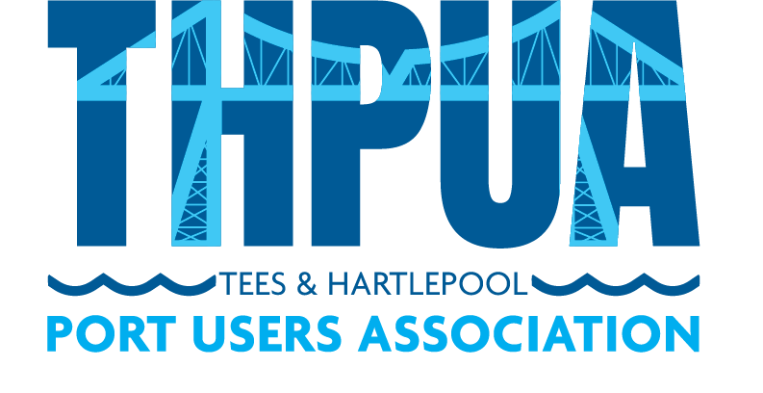

AGENDA
for an online Zoom meeting
to be held at 10:00hrs on Wednesday 14 July 2021

- Welcome

- Apologies

Apologies and members not represented will be detailed in the minutes.

- Minutes
Approval of minutes of last meeting
Updates on outstanding actions from last meeting

- Matters Arising
High Tide Foundation - Lauren Bywater & Michael Shakesheff
Equinor - Tom Nightingale

- Correspondence

- Health, Safety & Environment

COVID-19

- Port Business

Report of river tonnages & vessels in/out (KR)

Teesport Masterplan 2020

Policy - Freezone/EU Exit, Red diesel relief 2023

- Port Promotion

- Port Liaison

Oil Pollution Recovery Convention (OPRC)

International Ship and Port Security (ISPS)

Port Resilience Group (SB)

Port Levy & Welfare Report (AF/AW/PB)

- Finances

- Sports and Social

- AOB

- Date and Time of next meeting
10am on 8 Sept 2021 via Zoom/Venue TBC.

