MINUTES OF THE TWENTY FIFTH ANNUAL GENERAL MEETING

WEDNESDAY 8 DECEMBER 2021

AT WHINSTONE VIEW, B1292, MIDDLESBROUGH TS9 6QG

& ONLINE VIA ZOOM

1. | Attendees  (25 attendees: from 19 member orgs and 1 guest member org)
 | Augean | Terry Blanchard, Joseph Newman
 | AV Dawson Limited | Gary Dawson (Chair)
 | B Marshall Marine | Chris Jakeman
 | Bulk Tainer | David Eltherington
 | Casper Shipping | Michael Shakesheff, Neil Martin (Nom Com Chair)
 | CL Prosser & Co Limited | Robert Bainbridge
 | ConocoPhillips Petroleum Co UK Ltd | Stuart Brookes*
 | Graypen Limited | Christian Melvin (Treasurer), Matthew Todd
 | Harbour Management Solutions Ltd | Alexe Finlay*
 | LV Shipping UK | Matt Ord
 | Navigator Terminals | Michael Chaney, John Marshall
 | PC Logistics | Stephen Browell
 | Port of Middlesbrough | Charlie Nettle (Secretary)
 | Redcar Bulk Terminal | Shaun Casey
 | SMS Towage | Simon Clarke
 | Svitzer Marine Ltd | Gavin Girling*
 | Tees Bay Pilots | Andy Armstrong, Colin Pratt
 | Tees Foyboatmen | Ellis Appleton, Lee Scott
 | Teesworks | Garry O’Malley (Vice Chair)

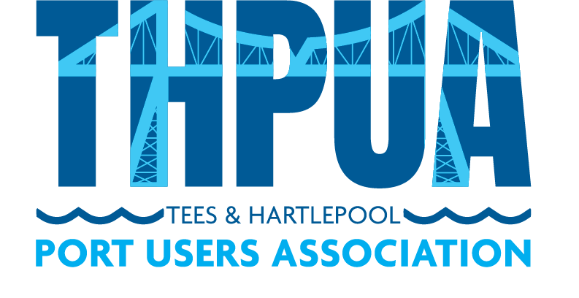
 |  | Action
2. | Apologies  Guest members North Tees Mission & Stella Maris were unable to attend.  Of 59 member companies, 40 were not represented. These were AbleUK, Agility Logistics, A&P Group, Anglo American, BG Freightline, British Steel, CF Fertilisers, Cockfield Knight, Cook Marine Ltd, Cory Bros, CSG Recyc-Oil, Denholm Port Services, Exolum, Fairfield Industries, GAC Shipping UK Ltd, Huntsman Polyurethanes, Hutchinson Transport, ICL UK, Inchcape Shipping Services (UK) Ltd, Intertek Testing Services, International Marine Survey, Jalna Marine Services, KRS Marine, LG Maritime, Liberty Steel Hartlepool, MGT Teesside, MPI Offshore, PD Group Management, Portrack Seafreight, Prysmian Group, Readman Steel, Red Lion Marine, River Tees Engineering, Sabic Europe, SGS, Steel Benders UK, Stobart Energy, UK Marine Surveys, Waste Knot, Wilton Group.
3. | Minutes of the 2020 AGM  Adopted on a proposal by Matthew Ord, seconded by Alexe Finlay.  The Secretary reported that all actions have been completed.
4. | Annual Report  The Chair advised that his report would be circulated with the papers. He advised that he would like to continue to be involved in the THPUA but will also be introducing a colleague to attend the majority of the meetings.  Secretary to recirculate the Chair’s annual report with the minutes. | CN
5. | Presentation of Accounts  The Treasurer advised that the accounts would be available for presentation in January 2022 or possibly February 2022 latest.
6. | Appointment of Auditor  The Treasurer formerly thanked the current auditor, Beaumont and recommended that the THPUA continue with them for another year. This was proposed by the Chair and seconded by Robert Bainbridge.  Treasurer to send thank you to Beaumont and invite them to continue next year. | CM
7. | Annual Subscriptions  The Treasurer advised that this is currently £150 per year and stated that he felt it was appropriate to leave it at this level. The Chair asked for members views. All agreed the rate should be held at £150 per annum. This was proposed by the Ellis Appleton and seconded by Michael Chaney.
8. | Honoraria  The Chair advised that usually the Secretary, Treasurer and Dinner Secretary would step out of the room for this discussion but he suggested this was not necessary.  Members agreed to continue with the current arrangement of £550 per quarter to the Secretary, £250 per quarter to the Treasurer and £500 per annum to the Dinner Secretary. This was supported with a show of hands.  Stephen Browell asked how the Dinner Secretary payments would be impacted under the new joint dinner with ICS. The Secretary advised that he had spoken with Gillian Clark, ICS North East Chair and she had advised that ICS was not keen to renumerate their representatives on the dinner committee. The Secretary advised that he had proposed to Gillian that the THPUA representative continue to receive the payment but be charged with responsibility for chairing the committee and Gillian was broadly comfortable with this.  The Chair advised that Alexe Finlay and Mandy Shoosmith have managed the dinner for 20 years and with the move to a joint event Alexe had felt it time to step down. The Chair advised that while flowers were presented to Alexe at the dinner, a further gift has been purchased of dinner at Crathorne Arms. As Alexe was attending the meeting online, the gift letter from the owner of Crathorne Arms will be presented to Alexe and Mandy when the Secretary next sees them. | CN
9. | Election of Officers  The Chair advised that the Chair and Vice Chair roles were due for election this year. He thanked the current Vice Chair for his support over the last two years. He asked for a show of hands to check that all members present gave verbal agreement to appointing Garry O’Malley as Chair. This was unanimously agreed.  The new Chair thanked the former Chair for his leadership and the Treasurer presented him with some gifts.  The new Chair took over chairing the meeting. He advised of the recent work the nominations committee had been undertaking to identify a new Vice Chair and recommended that Matt Ord be put forward for this role. It was unanimously agreed.  Neil Martin updated on the nominations committee’s latest progress in recruiting a dinner secretary. He advised that a few people have put their names forward and a decision should be made by next meeting.
10. | Confirmation of Officers  The new Chair asked for a show of hands to check that all members present gave verbal agreement to the following reappointments:  Treasurer Christian Melvin  Secretary Charlie Nettle  This was unanimously agreed.
11. | 2022 Meeting Schedule  The Secretary reported that the first quarter of the year is expected to be via Zoom meetings and hopefully AV Dawson’s new head office will host the first physical meeting.  Secretary to circulate 2022 meeting dates.  Members to confirm venues and member presentation slots to Secretary.  Colin Pratt confirmed that Tees Bay Pilots would host the July meeting. | CN  All
12. | Any Other Business  None.

