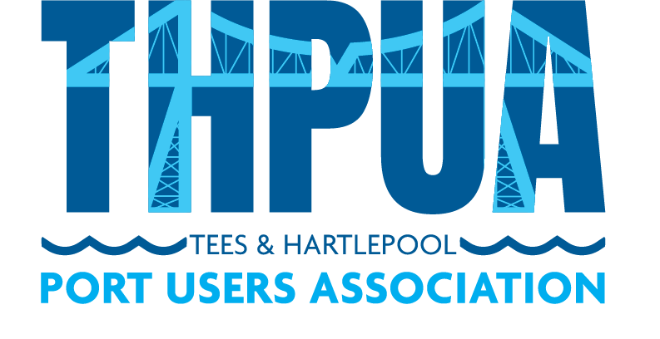

AGENDA
for an online Zoom meeting
to be held at 10:00hrs on Wednesday 9 March 2022

- Welcome

- Apologies

Apologies and members not represented will be detailed in the minutes.

- Minutes
Approval of minutes of last meeting
Updates on outstanding actions from last meeting

- Matters Arising
Crown Estates – Dave Nunn
Port Marine Safety Code Presentation – Chris Stocks, PD Ports

- Correspondence

- Health, Safety & Environment

COVID-19

- River Operations

Towage

Pilots

Foyboatmen

Dredging

- Port Business

Report of river tonnages & vessels in/out (KR)

Freeport and Customs updates

- Port Promotion

- Port Liaison

Oil Pollution Recovery Convention (OPRC)

International Ship and Port Security (ISPS)

Port Marine Safety Code Group (SB)

Port Levy & Welfare Report (AF/AW/PB)

- Finances

- Sports and Social

- AOB

- Date and Time of next meeting
10am on 13 April 2022 via Zoom

