MINUTES OF THE TWENTY SIXTH ANNUAL GENERAL MEETING

HELD AT 12:00 HRS WEDNESDAY 14 DECEMBER 2022

AT WHINSTONE VIEW, B1292, MIDDLESBROUGH TS9 6QG

1. | Attendees
 | (23 attendees: from 18 member orgs,1 honorary member org)
 | AV Dawson Limited |  | Charlie Nettle (Secretary)
 | BG Freightline |  | Neil Johnson, Adam Jefferson
 | Casper Shipping |  | Nikki Sayer
 | CL Prosser & Co Ltd |  | Robert Bainbridge
 | Cockfield Knight |  | Richard Booth (Dinner Comm Chair)
 | ConocoPhillips Petroleum Co UK Ltd |  | Stuart Brookes, Lisa Smith, Matt Cooke
 | Harbour Management Solutions Ltd |  | Alexe Finlay
 | ICL UK |  | Mark Wilson
 | LV Logistics |  | Matt Ord (Vice Chair)
 | Navigator Terminals |  | Jon Marshall, Michael Chaney
 | PC Logistics |  | Stephen Browell
 | Port of Middlesbrough |  | Gavin McCabe
 | Redcar Bulk Terminal |  | Shaun Casey
 | SMS Towage |  | Simon Clarke
 | Svitzer Marine Ltd |  | Gavin Girling
 | Tees Bay Pilots |  | Colin Pratt
 | Tees Foyboatmen |  | Alex Jones, Lee Scott
 | Teesworks |  | Garry O’Malley (Chair)
 | South Tees Mission to Seafarers |  | (Alexe Finlay – as recorded above)

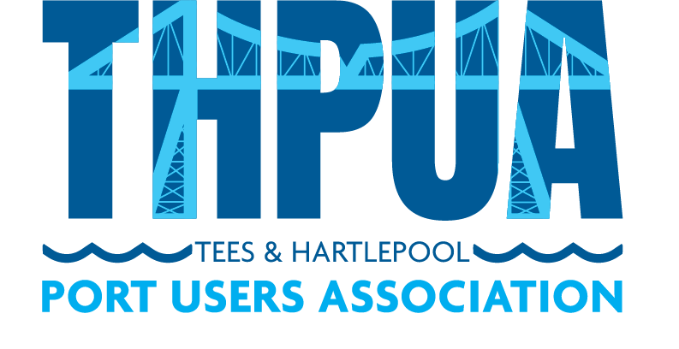
 |  | Action
2. | Apologies  The Secretary advised that the Treasurer had given apologies but has provided a full hand over to the Secretary for his items during the meeting.  Apologies received from honarary members Stella Maris and North Tees Mission to Seafarers.  Of 63 member companies, 45 were not represented. These were AbleUK, Agility Logistics, A&P Group, Anglo American, Augean, B Marshall Marine, British Steel, Bulk Tainer, CF Fertilisers, Cook Marine Ltd, Cory Bros, Croft Rigging & Lifting, CSG Recyc-Oil, Denholm Port Services, Exolum, Fairfield Industries, GAC Shipping UK Ltd, Graypen Limited, Huntsman Polyurethanes, Inchcape Shipping Services (UK) Ltd, International Marine Survey, Intertek Testing Services, Jalna Marine Services, KRS Marine, LG Maritime, Liberty Steel Hartlepool, MGT Teesside, M&S Logistics, MPI Offshore, PD Group Management, Portrack Seafreight, Prysmian Group, Readman Steel, Red Lion Marine, RelyOn Nutec, River Tees Engineering, Royal Haskoning DHV, Sabic Europe, SGS, Steel Benders UK, Stobart Energy, Sub Aqua Diving Services UK Ltd, UK Marine Surveys, Waste Knot, Wilton Group.
3. | Minutes of the 2021 AGM  Adopted on a proposal by Stephen Browell, seconded by Robert Bainbridge. The Secretary reported that all actions have been completed.
4. | Annual Report  The Chair gave an overview of the challenges in the world economy and commented about the resilience of the region and some of the recent investments in the area. He said that he felt that this area will buck the national trend. He advised that his report would be circulated with the papers. Secretary to circulate the Chair’s annual report with the minutes. | CN
5. | Port Levy and Missions Update  The Chair reported that this was a new agenda item. The Secretary advised that he has worked with the local seafarers’ welfare organisations to compile a review on how the £60,000 of donations has been used over the past year. The review is accompanied by a document that gives a summary on the Port Levy and how it is administered. These documents will also now be sent out to agents to help inform vessel owners of the great work of the welfare organisations. The Secretary passed on thanks to members for their support on behalf of all of the welfare organisations.  Alexe Finlay asked if she could share the Port Levy update with the Merchant Navy Board. The Secretary confirmed that it could be sent to anyone.  Secretary to circulate Port Levy update to members, add to THPUA website and send to ships agents to pass to vessel owners. | CN
6. | Presentation of Accounts  The Secretary advised that the 2022 accounts would be issued and audited and available for presentation in February 2023 meeting, or March latest.  The current bank balance is £21,403.44.
7. | Appointment of Auditor  The Secretary formerly thanked the current auditor, Beaumont and advised that it is the Treasurer’s recommendation that the THPUA continue with them for another year. This was proposed by Alexe Finlay and seconded by Stephen Browell.  Treasurer to send thank you to Beaumont and invite them to continue next year. | CM
8. | Annual Subscriptions  The Chair advised that this is currently £150 per year and stated that the officers felt it was appropriate to leave it at this level. The Chair asked for members views. All agreed the rate should be held at £150 per annum. This was proposed by Nikki Sayer and seconded by Shaun Casey.
9. | Honoraria  The Chair advised that usually the Secretary, Treasurer and Dinner Secretary would step out of the room for this discussion but he suggested this was not necessary.  Members agreed to continue with the current arrangement of £550 per quarter to the Secretary, £250 per quarter to the Treasurer and £500 per annum to the Dinner Secretary. This was proposed by Robert Bainbridge and seconded by Mark Wilson.  The Chair also advised that a gift will be sent to Mandy Shoosmith for organising today’s Christmas lunch.  Treasurer to send thank you gift to Mandy Shoosmith | CM
10. | Election of Officers  The Chair advised that the Chair and Vice Chair roles were not due for election this year. He thanked the current Vice Chair for his support over the last year.  The Chair advised that at next year’s AGM in December 2023, the Vice Chair will replace the Chair and the THPUA’s Nominations Committee, led by its Chair, Neil Martin, would coordinate the process of identifying a potential Vice Chair before this. | NM
11. | Confirmation of Officers  The Chair asked if all members present gave verbal agreement to the following reappointments:  Treasurer Christian Melvin  Secretary Charlie Nettle  Dinner Secretary Richard Booth (subject to ICS also supporting this)  This was proposed by Mark Wilson and seconded by Gavin Girling.
12. | 2023 Meeting Schedule  The Secretary reported that as previously agreed, once a quarter there will be a face-to-face meeting but all other meetings will be via Zoom.  Chris Jakemen asked about whether the welfare organisations had presented. Members confirmed this had been done recently and also the Port Levy review that is due to be circulated will hopefully provide a sufficient update.  Secretary to circulate 2023 meeting dates.  Members to confirm if they have suitable venues, whether they wish to do a member presentation and whether there are any external organisations they would like the THPUA to invite to present at a future meeting. | CN  All
13. | Any Other Business  None.

