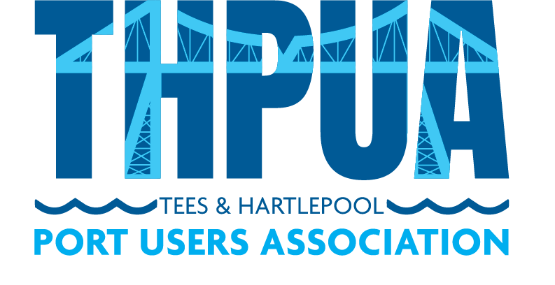

2022 CALENDAR

Meeting Date | Venue (online also available) | Venue Organiser | Member/External  Presentations
12 January | Zoom Meeting | N/A | NE School of Shipping
9 February | Zoom Meeting | N/A
9 March | Zoom Meeting | N/A | PD Chris Stocks – PMSC  Crown Estates
13 April | Zoom Meeting | N/A | Augean Presentation
11 May | AV Dawson’s new HQ | AV Dawson (CN) | B Marshall Marine (CJ)  AV Dawson (GD)
8 June | Zoom Meeting | N/A
13 July | Hartlepool Yacht Club | Tees Bay Pilots | Bulk Tainer (DE)  Harbour Police (MJ)
14 September | Zoom Meeting | N/A | ICHCA (GM)  OPRC (A.Ridley)
12 October | Zoom Meeting | TBC | Croft Rigging (MC)  Tees Wheelyboats (Tony Campbell)
9 November | Zoom Meeting | TBC | Protium (Ian Collier)  SOBS (Sally & Michelle)
14 December | Whinstone View | HMS (MS) | None

Event Date | Event | Venue | Tickets/Organiser
29 July ’22 | THPUA Cricket Match | Hutton Rudby | £0 (R.Chambers)
Fri 15 July ‘22 | THPUA Golf Day | Wynyard | £TBC per team (K.Ness)
25 Nov ‘22 | THPUA/ICS Joint Dinner | Kirkleatham Walled Garden | £TBC
14 Dec ‘22 | THPUA AGM & Christmas Lunch | Whinstone View | £0

