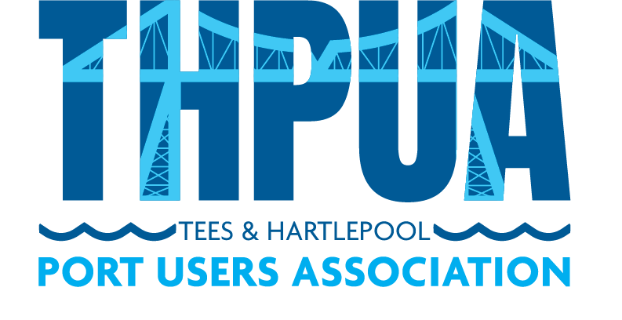

CODE OF CONDUCT

FOR OFFICERS, COMMITTEES & WORKING GROUPS

Introduction

The Code of Conduct (herein referred to as “the Code”) for the Tees & Hartlepool Port Users’ Association (herein referred to as “the THPUA”) contains the expected minimum professional and ethical standards that all Officers must uphold. The Code also applies to any person appointed to a Committee, Working Group or any other role where a person has been given authority to act as a representative of the THPUA.

While in any of the aforementioned roles or groups, Members must at all times act in line with the Code bringing their professional knowledge in other roles, such as leadership, education, shipping, finance or research etc. The values and principles set out in the Code can be applied in a range of different settings, but they are not negotiable or discretionary.

General Principles & Intent

Guided by best practice, the following Code applies to all Members during their tenure on any of the aforementioned groups. The Code sets out to achieve Member’s compliance with the following main objects and general principles:

- Act with Integrity
- Act with Respect & Professionalism
- Act in the best Interests of the THPUA at all times

In order to achieve and comply with these principles it is the responsibility of each Member to;

- Act with Integrity

  - Disclose in writing details of any employment and business or other interests which are in conflict or potentially in conflict with the role as a Member. This should include connections or connected persons or companies that are supplying goods or services to the THPUA. Any conflicts of interest that arise will be dealt with at board meetings, committees and working groups, whose decision on the matter will be final.
  - Not accept corporate gifts, hospitality, preferential treatment or benefits from any party (or other member) which might impact or appear to impact their independent judgment in terms of them acting in the best interests of the THPUA at all times.
  - Shall declare any conflict of interest should it arise in respect of payment for services from the THPUA while serving as Members of the board, committees or working groups.
  - If claiming expenses from the THPUA you will ensure that your claims are honest and verifiable and in accordance with good practice and the guidelines set down by the THPUA under its Expenses Policy.
  - Avoid the use of the THPUA resources or time for personal gain, for the benefit of persons or entities unconnected with the THPUA or its activities, or for the benefit of outside interests.
  - Treat all information and disclosures with confidentiality and share only with intended parties as directed and agreed by Controlling Council.

- Act with Respect & Professionalism
  - Respect, follow and obey the THPUA governance, rules and regulations both literally and implied.
  - Treat others with respect and professionalism and respect the skills, expertise and contributions of your fellow Members and Staff.
  - Act with honesty and integrity at all times, treating people fairly and without discrimination, bullying or harassment.
  - Deal with differences of professional opinion with colleagues by discussion and informed debate, respecting their views and opinions and behaving in a professional way at all times.
  - Not unfairly discriminate by allowing your personal views to affect your professional relationships with other Members or Staff.
  - Maintain your competence to carry out your role and keep your professional knowledge and skills up to date to enable you to perform your role satisfactorily.
  - Be aware at all times of how your behaviour can affect and influence the behaviour of other people
  - Act in accordance with all applicable UK legislation, rules and regulation and use these as minimum standards.
  - Treat people in a way that does not take advantage of their vulnerability or cause them to become upset or distressed.
  - Stay objective, remain focused in meetings and have clear professional boundaries at all times.
  - Use all forms of spoken, written and digital communication (including social media and networking sites) responsibly, respecting the right to privacy of others at all time.
  - Act always within any given authority.

- Act in the best interests of the THPUA at all times
  - Not misrepresent the THPUA or any members for personal or professional benefit or for the benefit of a family member, friend or associate.
  - Share any concerns or risks with respect to the THPUA in an appropriate manner for consideration of the board, committees and working groups.
  - Place highest priority in protecting the wellbeing and health of the THPUA Members.
  - Respect the decisions of the board that shall be made by consensus and which should be in the best interests of the THPUA at all times.
  - Endeavour to attend all meetings (of which they are a member) and actively participate and contribute at those meetings.
  - Be prepared and have read all relevant agenda papers in advance of the meetings.
  - Respect the meeting procedures and interject via the Chair.
  - Shall not speak or attempt to represent the views on behalf of the THPUA to the media or in public forums or social media platforms without the prior written consent of the THPUA officers.
  - Comply with all relevant provisions with respect to THPUA policies concerning General Data Protection Regulation. (GDPR)
  - Will ensure that any report or statement issued by the board, committees and working groups accurately reflects the THPUA’s position and is not misleading or designed to mislead.

Name: ……………………………………………..………………………………………………….

Board/Committee/Group: ………………………………………………………………………..

Signature: ……………………………….…………………... Date: …………….........................

