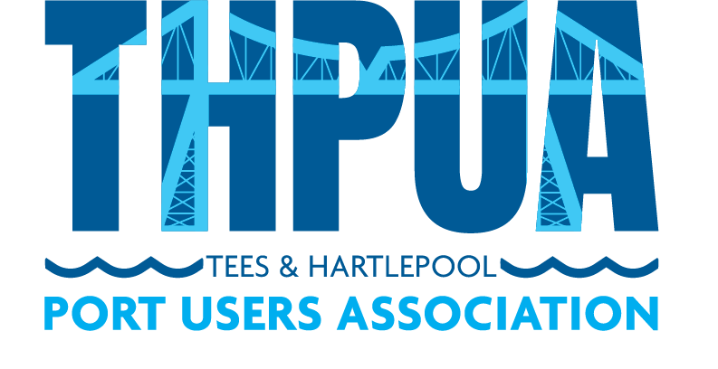

AGENDA
for a meeting to be held at 10:30hrs on Wednesday 14 December 2022
at Whinstone View, B1292, Middlesbrough TS9 6QG

followed by the AGM (agenda circulated)

and lunch (menus circulated)

- Welcome

- Apologies

Apologies and members not represented will be detailed in the minutes.

- Minutes
Approval of minutes of last meeting
Updates on outstanding actions from last meeting

- Matters Arising

- Correspondence

- Health, Safety & Environment

- River Operations

Towage

Pilots

Foyboatmen

Dredging/Dredging portal

- Port Business

Report of river tonnages & vessels in/out (KR)

Freeport and Customs updates

- Port Promotion

- Port Liaison

Oil Pollution Recovery Convention (OPRC)

International Ship and Port Security (ISPS)

Port Marine Safety Code Group (SB)

Port Levy & Welfare Report (AF/AW/PB)

- Finances

- Sports and Social

- AOB

- Date and Time of next meeting
10am on Wednesday 11 January 2023 via Zoom

