MINUTES OF AN EXTRAORDINARY GENERAL MEETING

WEDNESDAY 9 NOVEMBER 2022

ONLINE VIA ZOOM

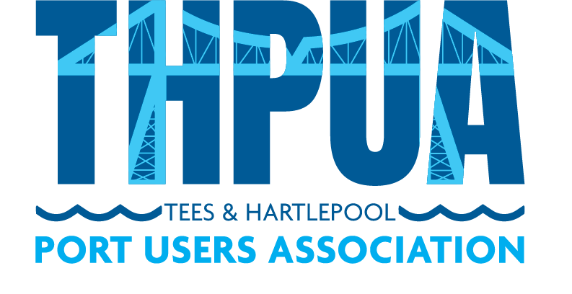
- Attendees

(24 attendees: from 20 member orgs)
Augean | David Bumpstead
AV Dawson Limited | Charlie Nettle (Secretary)
British Steel | Graham Palmer
Casper Shipping | Michael Shakesheff, Nikki Sayer,  Dave Gibbin, Neil Martin (NomCom Chair)
CL Prosser & Co Ltd | Robert Bainbridge
ConocoPhillips Petroleum Co UK Ltd | Stuart Brookes
Exolum | Graham Bell
Graypen Limited | Christian Melvin (Treasurer)
Harbour Management Solutions Ltd | Alexe Finlay
Huntsman Polyurethanes | Jonathan Clarke
ICL UK | Mark Wilson
Inchcape Shipping Services (UK) Ltd | Luke Slater
LV Logistics | Matt Ord (Vice Chair)
Navigator Terminals | Jon Marshall
PD Group Management | Keith Russell
SMS Towage | Michael Halasz
Svitzer Marine Ltd | Gavin Girling
Tees Bay Pilots | Colin Pratt, Andy Armstrong
Tees Foyboatmen | Alex Jones
Teesworks | Garry O’Malley (Chair)

 |  | Action
2. | Apologies  Of 63 member companies, 43 were not represented. These were AbleUK, Agility Logistics, A&P Group, Anglo American, B Marshall Marine, BG Freightline, Bulk Tainer, CF Fertilisers, Cockfield Knight, Cook Marine Ltd, Cory Bros, Croft Rigging & Lifting, CSG Recyc-Oil, Denholm Port Services, Fairfield Industries, GAC Shipping UK Ltd, International Marine Survey, Intertek Testing Services, Jalna Marine Services, KRS Marine, LG Maritime, Liberty Steel Hartlepool, MGT Teesside, M&S Logistics, MPI Offshore, PC Logistics, Port of Middlesbrough, Portrack Seafreight, Prysmian Group, Readman Steel, Redcar Bulk Terminal, Red Lion Marine, RelyOn Nutec, River Tees Engineering, Royal Haskoning DHV, Sabic Europe, SGS, Steel Benders UK, Stobart Energy, Sub Aqua Diving Services UK Ltd, UK Marine Surveys, Waste Knot, Wilton Group.
3. | Purpose of EGM  The Chair welcomed members and advised them of the purpose of the EGM.  He stated that the purpose was to approve the replacement of the Constitution with new Articles of Association and a supporting Rules document and also to incorporate the Association.  [As noted on the agenda, the Constitution may only be altered by a Special Resolution by a majority of those present at an Extraordinary General Meeting called for that purpose].
4. | Overview of rationale for incorporating  The Secretary referred to a paper entitled ‘Proposal to Professionalise the THPUA’, which he had written and circulated prior to the January 2022 THPUA meeting and which was discussed with members during the meeting, in Any Other Business.  The Secretary recapped on the main points raised in the paper, which were that the THPUA had grown significantly since the original constitution was written and the THPUA now had a higher profile and a more influential role. This has the potential to result in personal liabilities for officers and members as a result of the actions of the officers and the Association. The officers therefore suggested that more robust governance was now required to protect the Association, its officers and members. The recommended option (Option 2) detailed in the proposal was to incorporate as a ‘Not-For-Profit Trade Association, Limited by Guarantee, without share capital’. Members were supportive of the proposal but with the omission of the ‘trade association’ classification (due to the lobbying connotations this had). Members therefore supported a new ‘Option 3’, which was to incorporate as a ‘Not-For-Profit Organisation, Limited by Guarantee, without share capital’.  The Secretary advised that the THPUA officers have progressed with preparations on this basis. This has involved working with a legal adviser on draft Articles of Association and a draft Rules document, to replace the Constitution – which is not sufficient for an incorporated organisation.  He summarised by stating that incorporating would provide a professional footing on which to move forward and would also better protect the members and officers (who currently are all liable for the THPUA actions whereas as a limited organisation, liability for each member can be limited to £1).
5. | Overview of proposed changes within new Articles of Association  The Secretary referred to the draft Articles of Association that had been circulated with the EGM papers, along with a document entitled ‘THPUA Articles - Briefing for Members on main changes from Constitution and Model Articles.’ He explained that this paper captured the fundamental changes between the original Constitution and the new Articles.
6. | Overview of proposed ‘Rules’ document  The Secretary advised members about the legal advice he had received to create a separate ‘Rules’ document to capture more specific information that is not usually included in the published Articles of Association and is more likely to need amending in time. He referred to the draft Rules document that had been circulated with the papers.
7. | Questions from members  The Secretary asked for questions from members. Michael Shakesheff reiterated the importance of the Conflict of Interests clauses so as to ensure officers are unable to drive personal benefit from the role. He confirmed that the details in the draft documents addressed this point sufficiently.  Michael Shakesheff suggested that Code of Conduct for officers be included, as this approach works well for the ICS. Members agreed this was a good idea. The Secretary proposed that this be added on the Rules document and a separate Code of Conduct be drafted, using the ICS one as a template. All members were comfortable to approve the Rules document on this basis. | CN
8. | Votes and results  The Chair asked members to vote on each of the online polls below, with just the primary contact from each member company being eligible to submit a vote (as it is one vote per member company).  - Special Resolution (75% of votes) for member approval of proposed new Articles of Association to replace the current Constitution.  Result: The Secretary counted the votes and confirmed that 15 votes had been received; 100% (15 votes) in favour, no votes against. The new Articles are therefore approved.  - Ordinary Resolution (Majority vote) for member approval of supporting ‘Rules’ document.  Result: The Secretary counted the votes and confirmed that 14 votes had been received; 100% (14 votes) in favour, no votes against. The new Rules document is therefore approved.  - Special Resolution (75% of votes) for member approval to incorporate the Association as a company limited by guarantee.  Result: The Secretary counted the votes and confirmed that 14 votes had been received; 100% (14 votes) in favour, no votes against. The proposal to incorporate is therefore approved.  [Note: Richard Booth (Cockfield Knight) was unable to stay for the meeting but advised that he was in favour of the votes above. Shaun Casey (RBT) had given apologies and confirmed by email that he was also in favour.]
9. | Next steps  The Chair advised that the Secretary will now progress with the incorporation and securing Directors & Officers insurance once this is in place.
10. | Any Other Business  None.

