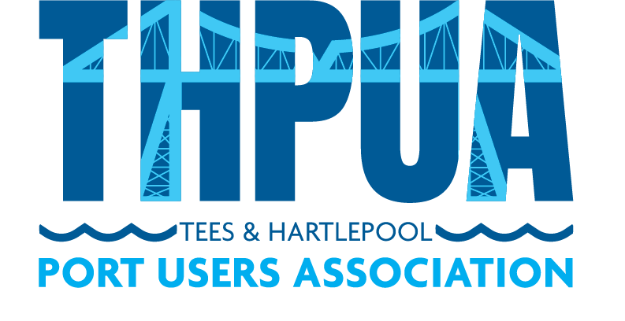

AGENDA
to be held at 10:30hrs on Wednesday 8 March 2023
@ AV Dawson’s Port of Middlesbrough, TS2 1LE
followed by buffet lunch at 12:00hrs (sponsored by Casper Shipping)

- Welcome

- Apologies

Apologies and members not represented will be detailed in the minutes.

- Minutes
Approval of minutes of last meeting
Updates on outstanding actions from last meeting

- Matters Arising
ICC Centre for Digital Trade & Innovation - Thobie Nyirongo
PD Port Community System - Chris Stocks

- Correspondence

- Health, Safety & Environment

- River Operations

Towage

Pilots

Foyboatmen

Dredging/Dredging portal

- Port Business

Report of river tonnages & vessels in/out (KR)

Freeport and Customs updates

- Port Promotion

- Port Liaison

Oil Pollution Recovery Convention (OPRC)

International Ship and Port Security (ISPS)

Port Marine Safety Code Group (SB)

Port Levy & Welfare Report (AF/AW/PB)

- Finances

- Sports and Social

- AOB

- Date and Time of next meeting
10am-12pm on Wed 12 April 2023 online via Zoom

