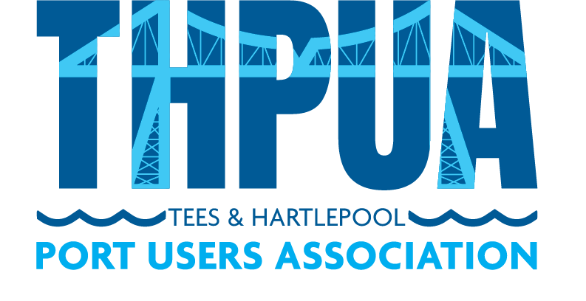

AGENDA
for an online Zoom meeting
to be held at 10:00hrs on Wednesday 9 November 2022

- Welcome

- Apologies

Apologies and members not represented will be detailed in the minutes.

- Minutes
Approval of minutes of last meeting
Updates on outstanding actions from last meeting

- Matters Arising
- Protium Hydrogen Plant Presentation – Ian Collier
- SOBS (Survivors Of Bereavement by Suicide) Presentation – Sally Booth & Michelle McCluskey

- Correspondence

- Health, Safety & Environment

- River Operations

Towage

Pilots

Foyboatmen

Dredging/Dredging portal

- Port Business

Report of river tonnages & vessels in/out (KR)

Freeport and Customs updates

- Port Promotion

- Port Liaison

Oil Pollution Recovery Convention (OPRC)

International Ship and Port Security (ISPS)

Port Marine Safety Code Group (SB)

Port Levy & Welfare Report (AF/AW/PB)

- Finances

- Sports and Social

- AOB

- Date and Time of next meeting
11am-2pm on 14 December 2022 @ Whinstone View
Meeting & AGM, followed by lunch

