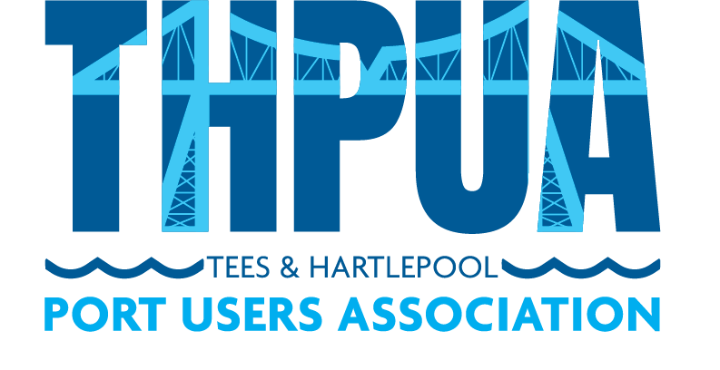

RULES OF

TEES & HARTLEPOOL PORT USERS’ ASSOCIATION

COMPANY NO: 14567461

- Purpose

This document should be referred to in conjunction with the THPUA Articles of Association. It provides more specific information and details that may change in the future. This document is not a public record and is therefore easier to update if the need were to arise. Any updates or amendments to these Rules must be approved by Ordinary Resolution.

- Rules
  - Appointing Directors
    - The addition or inclusion of directors (officers) is a decision for the members. An individual cannot be appointed as a director if either or both of the below apply:

      - They are not a member of the Association.
      - They are an employee of the Statutory Harbour Authority (as the objects of the THPUA include negotiation on tariffs and therefore presents a potential conflict of interests).

  - Code of Conduct for Officers, Committees & Working Groups
- As part of the application process, prospective directors (officers) are required to complete a form to confirm they agree to abide by the THPUA Code of Conduct. This document summarises the expected minimum professional and ethical standards that all officers must uphold. The Code also applies to any person appointed to a Committee, Working Group or any other role where a person has been given authority to act as a representative of the THPUA. Copies of the form are held by the Secretary.

  - Director Declarations of Interests
- As part of the application process, prospective directors are required to complete a form to declare their interests. This form is reviewed and updated each year for all directors. Copies of the form are held by the Secretary.

  - Member Conflict of Interests
- Members and directors must declare any potential conflicts of interests when joining the Association and at all member meetings where a potential conflict of interests arises. These should be declared to the directors, who will then take appropriate action.
- Appropriate action taken by the directors may include:
  - asking the member/director to leave the meeting while a particular agenda item is discussed;
  - advising the member/ director that they are unable to vote on an issue;
  - or terminating the member/director’s membership of the Association.
- Where a member/director has been found to have not disclosed a potential conflict of interests, the directors may take any of the actions listed in the point immediately above.

  - Funds
- Funds are used at the discretion of the directors, in line with the objects of the Association.

- The directors have a blanket authority for any gift of less than £500.

- Typically funds over £500 would be discussed and agreed with the wider membership’s approval.

  - Honorary Memberships
- The Honorary Membership category allows a business or individual to become a member of the Association, with the following differences:
  - No membership fee is required.
  - No voting rights are provided.

- Honorary membership is awarded at the discretion of the directors, in line with the objects of the Association.
- The directors have the authority to remove this category of membership from an individual or organisation at any time and without notice.
- This category of membership is typically awarded to the seafarers’ welfare organisations.

- Approval

The above Rules have been approved by Ordinary Resolution on the date as shown below and will be active from this date. These Rules will supersede any previous versions of these Rules.

Date of Ordinary Resolution: _______________________________

Confirmed by: THPUA Officer Name: _______________________________

THPUA Officer Signature: _______________________________

